
HELPING YOU NAVIGATE YOUR CHILD’S DIGITAL WORLD

Who: Parents of elementary and middle school students  When: Monday, October 28, 2019 6:00-7:30 PM  Where: Elsinore Middle School- MPR  Cost: Free to attend  Vaping is BIG BUSINESS, and our kids are the target. The drug culture is propagated by social media as well as EASY ONLINE ACCESS to vape devices, “vape juice”, and other liquefied drugs.  Clayton Cranford, a nationally recognized school safety expert and author of Parenting in the Digital World, will reveal the vape industry's strategy to market their addictive product to teens and how parents and educators can counter their deceptive message with science-based fact. It is illegal to sell vaping devices to minors. How are teens acquiring these devices? Students, in large numbers, are purchasing vapes from online stores. Clayton, the Cyber Safety Cop, will show parents how underaged students are purchasing vaping devices online and how to stop it from happening in their home.  Whether you are a parent, relative, or neighbor, we invite you to learn about this FAST GROWING trend and what you can do to help our children stay drug-free. Suitable for students and parents to attend together.  Clay Cranford will discuss:  - Trajectory of vaping technology  - Why a high percentage of teens are vaping  - Physical and health effects of nicotine and vape liquid  - How to talk to your child about using vaping devices  - Practical steps to help prevent children from acquiring vaping devices  For more information about the event:  Contact Elsinore Middle School |  |  | 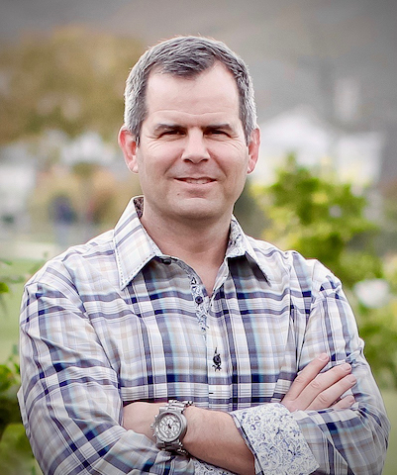  Clayton Cranford is a law enforcement professional, a former School Resource Officer and one of the nation’s leading educators on social media and behavioral threat assessments. He is the author of Parenting in the Digital World winner of the National Bullying Prevention Award.  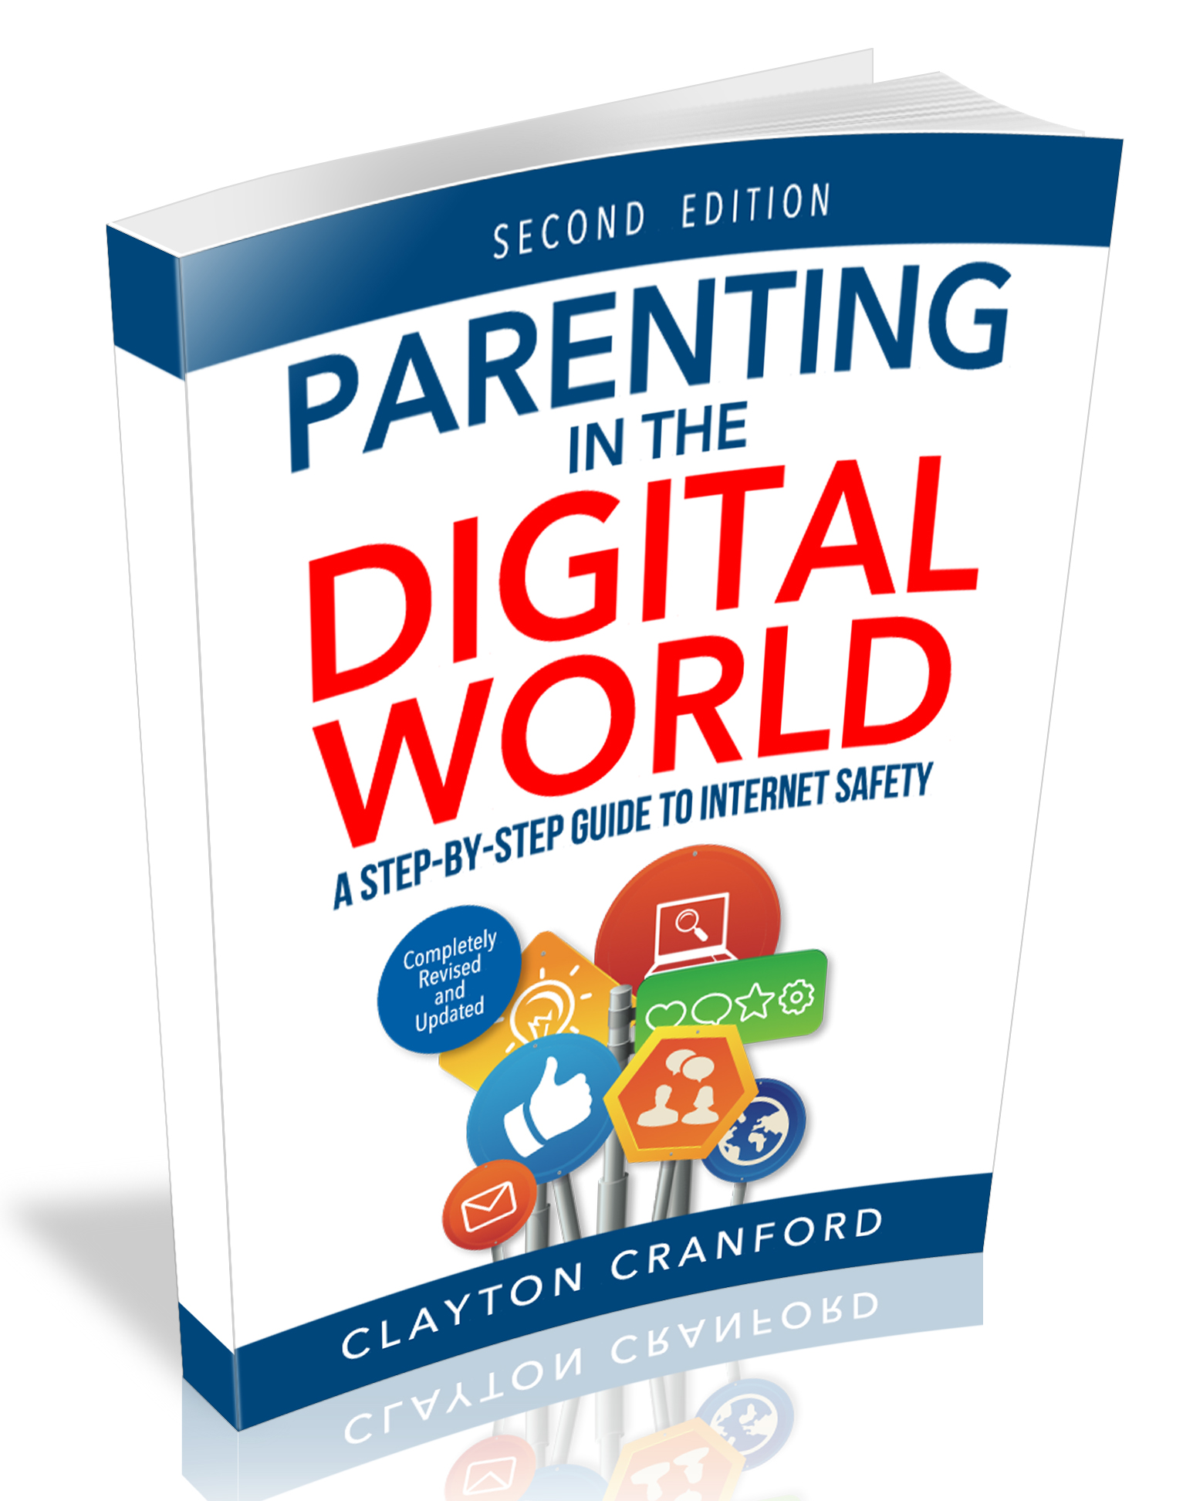  Clay Cranford’s book, Parenting in the Digital World, will be available for sale at the event. $20.00 (cash or credit card).  It is an important tool to making your child’s digital world safe. http://www.cybersafetycop.com/

